**Create an Azure AI services resource**

An Azure AI services resource allows you to access multiple Azure AI services with a single set of credentials.

You can access Azure AI services through two different resource kinds:

* Azure AI services **multi-service** resource:
  + Access multiple Azure AI services with a single set of credentials.
  + Consolidates billing from the services you use.
* **Single-service** resource such as Face and Vision:
  + Access a single Azure AI service with a unique set of credentials for each service created.
  + Most Azure AI services offer a free tier to try it out.

Azure AI services are Azure [resources](https://learn.microsoft.com/en-us/azure/azure-resource-manager/management/manage-resources-portal) that you create under your Azure subscription. After you create a resource, you can use the keys and endpoint generated to authenticate your applications.

**Supported services with a multi-service resource**

The multi-service resource enables access to the following Azure AI services with a single set of credentials. Some services are available via the multi-service resource and single-service resource.

**Create an Azure AI services multi-service resource**

**Step 1: Create an Azure AI Services Resource**

1. In the Azure portal, use the top search bar to search for Azure AI services.
2. Select Azure AI Services from the search results.

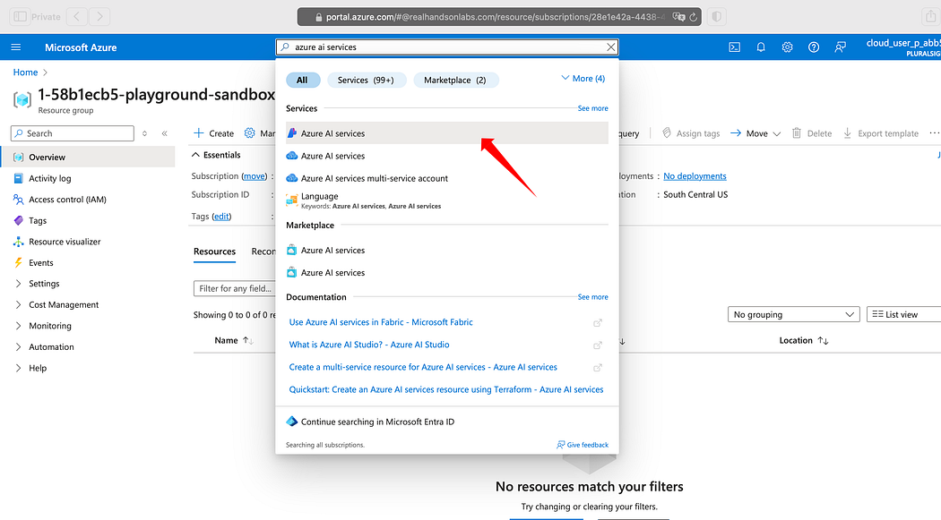

Click on Create to start provisioning a new multi-service account resource.

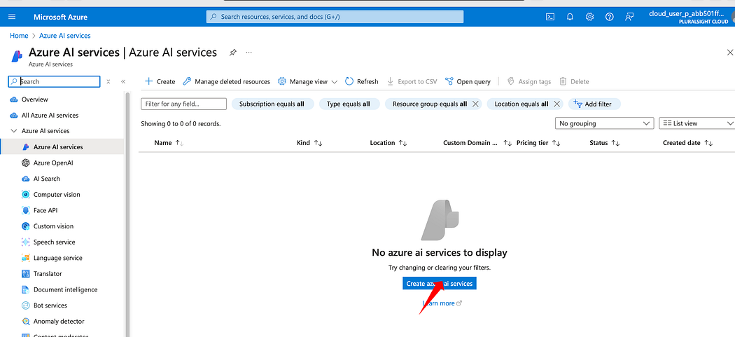

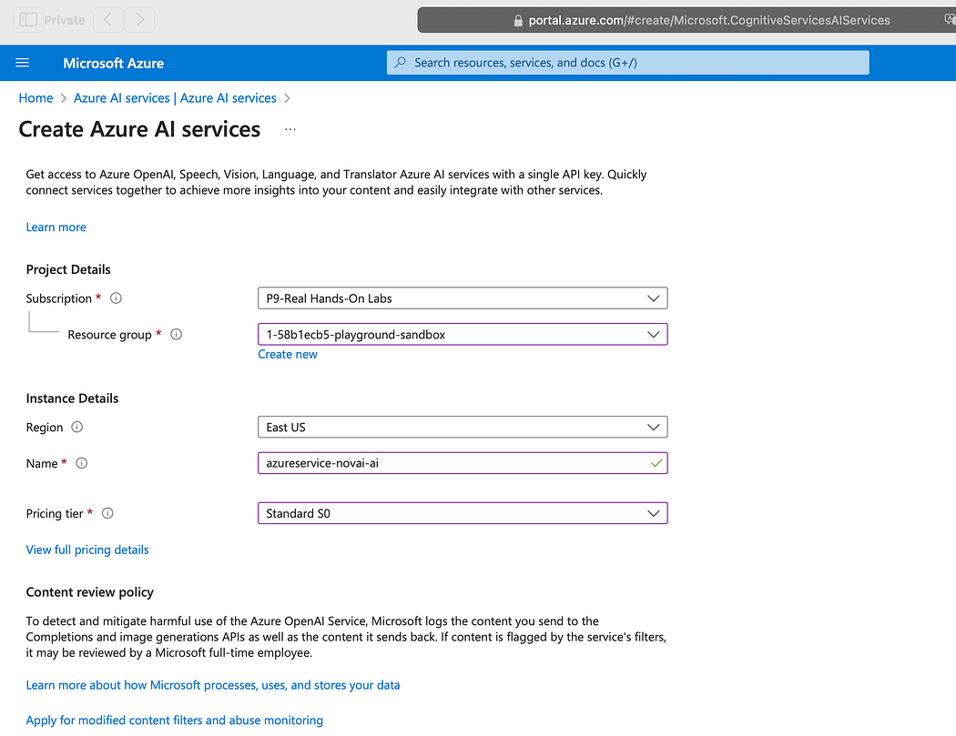

**Step 2: Configure Resource Settings**

When creating your Azure AI Services resource, you need to configure the following settings:

* **Subscription**: Select your Azure subscription.
* **Resource group**: Choose an existing resource group or create a new one. If you have restricted permissions, use the resource group provided to you.
* **Region**: Select an available region that fits your needs.
* **Name**: Enter a unique name for your resource.
* **Pricing tier**: Select Standard S0 for the pricing tier.

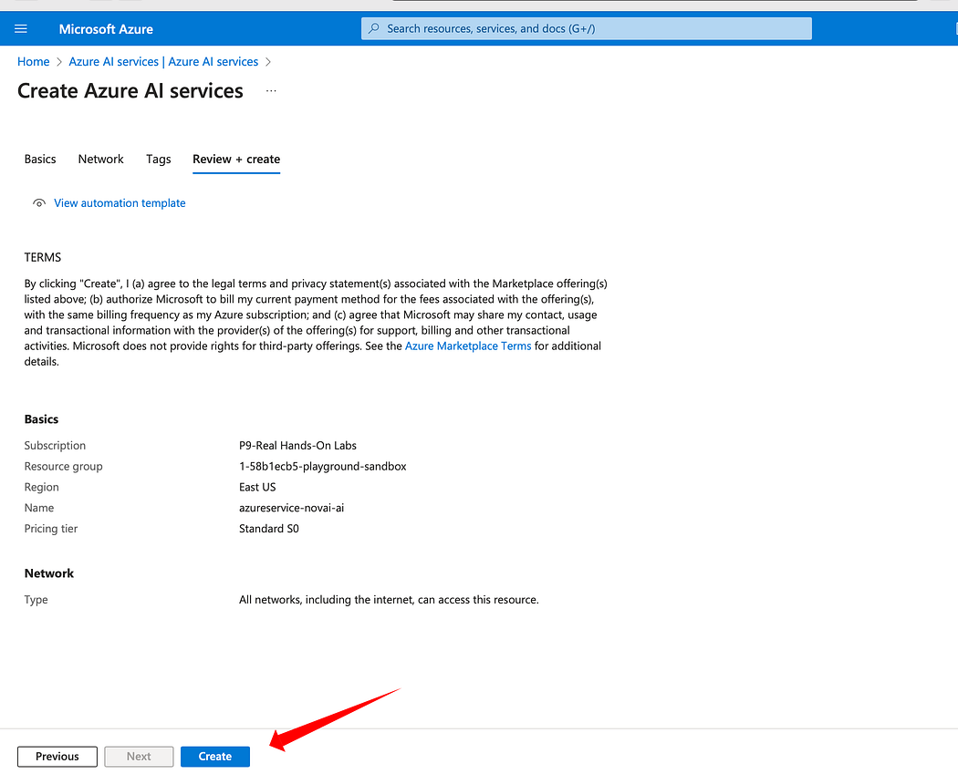

Step 4: Finalize and Create the Resource

1. Review the terms and conditions by selecting the required checkboxes.
2. Click Create to deploy your resource.
3. Wait for the deployment to complete. This process might take a few minutes.

